IPAY Self Service Registration

Welcome! ADP is committed to protecting your privacy and ensuring that only you can access your personal information. To assist us in meeting that commitment, you must register with us before using our services.

You will need your registration code (for example acme-abc1 or 9A7B632F) and the URL of your ADP service web site. Be sure to keep them handy.

On your ADP service web site, click the link to register for ADP services. Complete the following steps:

<https://portal.adp.com>

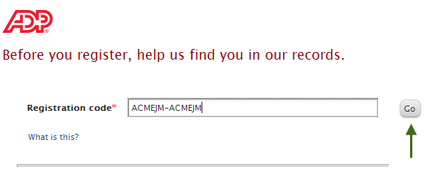

**Enter ASC Registration code: Call Payroll for code 607-753-4629**

If you do not have this information, contact your organization's administrator for assistance.

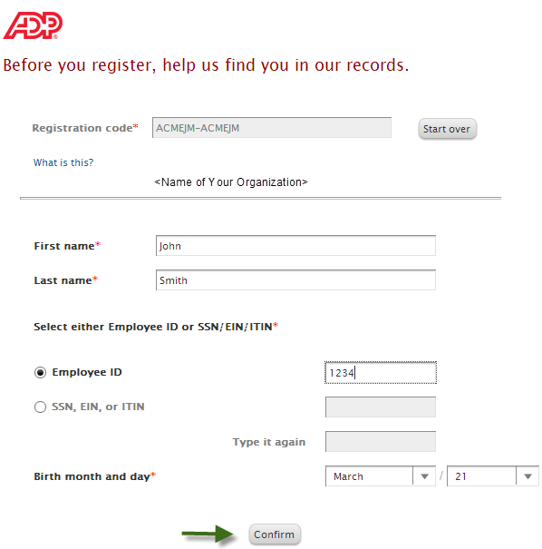

If this is not your organization, click Start over

The options available on this page might vary based on your organization’s setup.

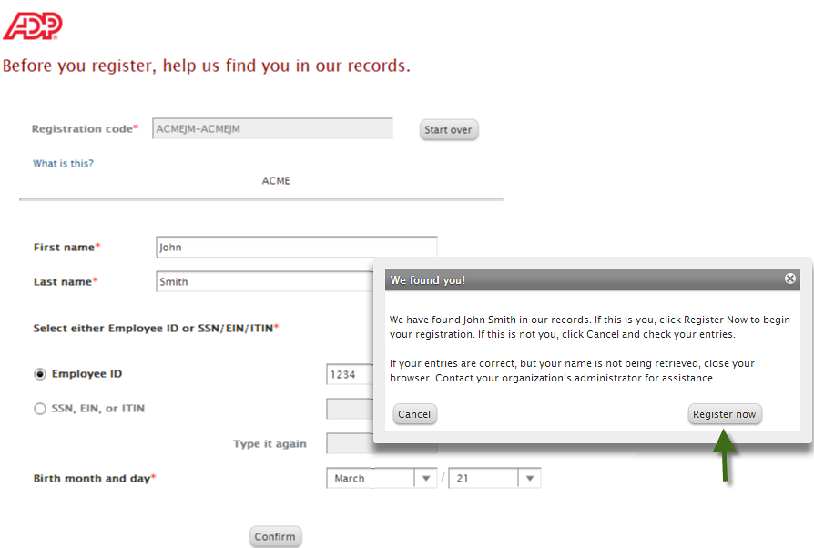

If your name is not being retrieved, contact your organization’s administrator for assistance.

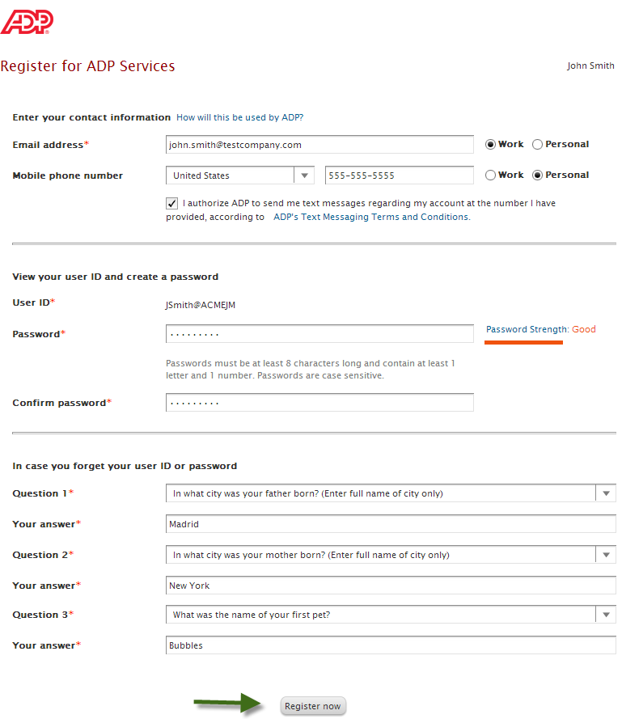

Create a strong password to protect your

account. Passwords are case-sensitive.

Your user ID and security answers are not case-sensitive.

Enter answers that you will remember later.

If you ever forget your user ID or password, you will be required to respond with the exact answers to confirm that you are the rightful owner of the account.

Depending on the ADP services your organization has purchased, the option to create your user ID might be available.

Notifications from your organization or ADP will be sent to this email/mobile phone. You may also use this information to retrieve your forgotten user ID or password.

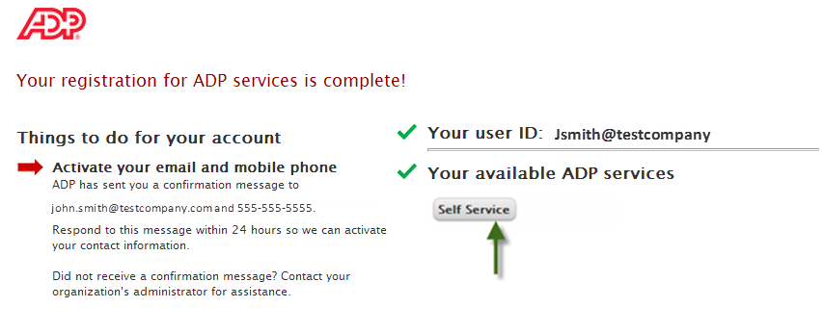

Your registration is complete. You can use your user ID and password to access your ADP service.

* You must activate your email and mobile phone number to receive important notifications from your organization or ADP.
* Manage your account information to keep it accurate.

Activate Your Email Address

Once you are registered, ADP will send you an email with instructions on how you can activate your email address. Click the link in the email you received from ADP to complete the activation.

Activate Your Mobile Phone

If you provided a mobile phone number during registration, look out for a text message from ADP. Reply with the code or follow the instructions in the text message to activate your mobile number. In the United States, the message will come from sender “90206”; the sender will vary in other countries.

Note: In some countries, this texting method to activate your mobile phone is not available, so your activation process will differ. Follow the instructions on the confirmation page and in the activation email you receive from ADP to complete the activation.

